A2200-Asia-China-Erlitou-Chüeh-Long Spout-1900-1500 BCE

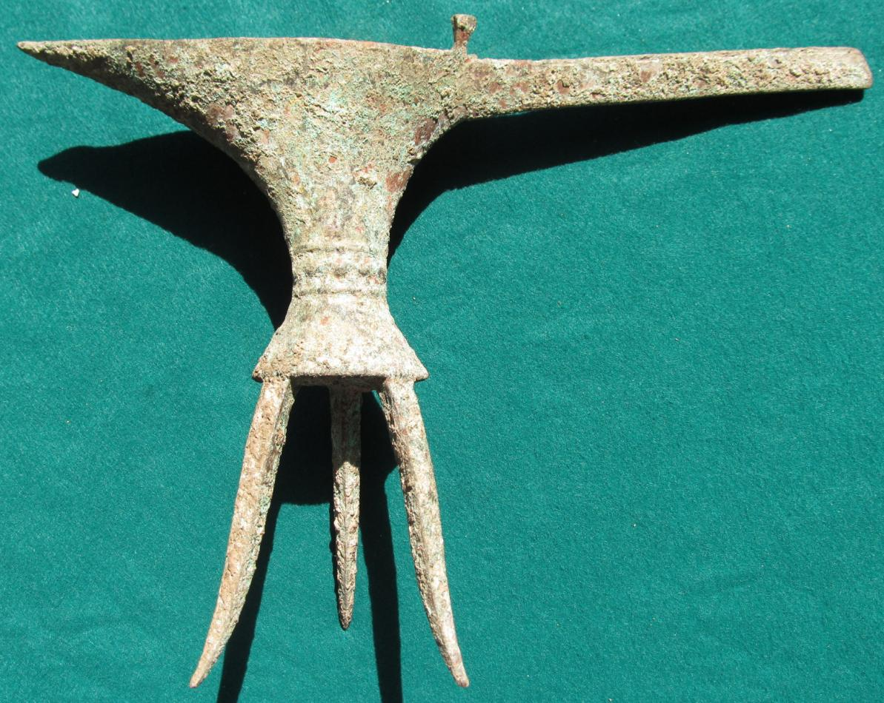

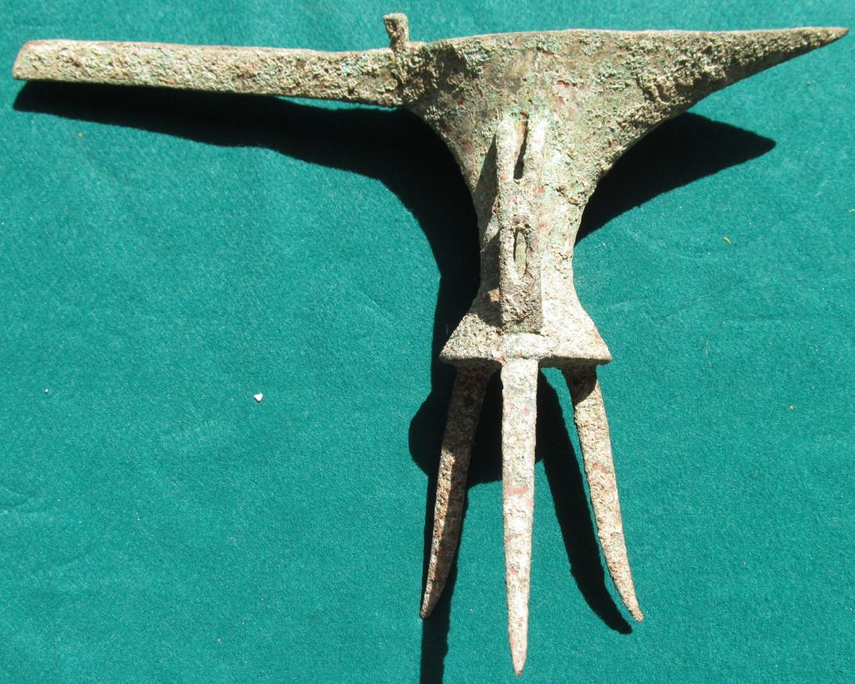

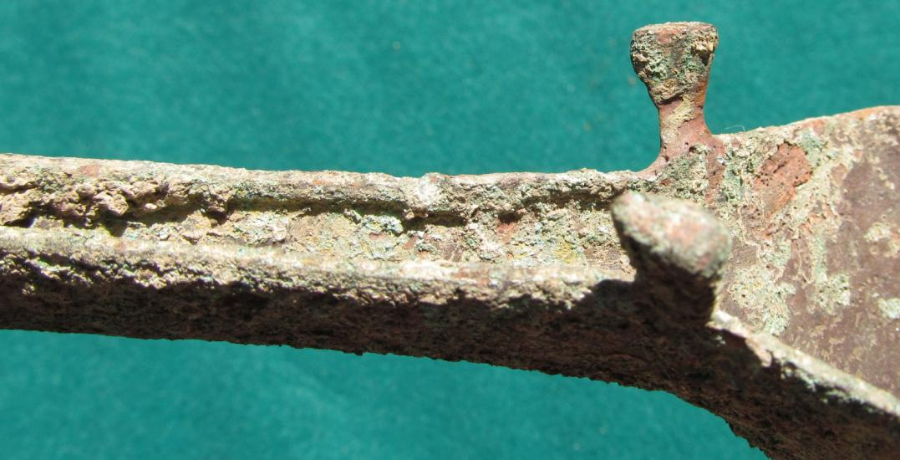

Case No.: 5

Accession No.

Formal Label:

**Display Description:**

This distinctive wine serving bronze ewer was the product of the Erlitou culture. The Erlitou early Bronze Age culture (1750 to 1530 BCE, Zhang et al. 2007) flourished in the Huang Ho (Yellow River) valley and diffused throughout Henan and Shanxi and later appeared in Shaanxi and Hubei.

Accession Number:

**LC Classification:**

Date or Time Horizon:

Geographical Area:

**Map:**

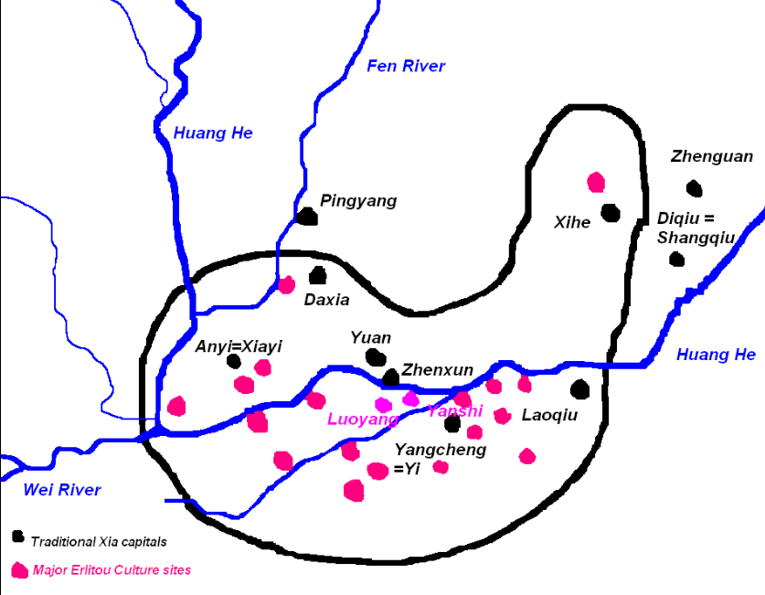

The Erlitou cultyure in red and the Xia culture in black after https://upload.wikimedia.org/wikipedia/commons/3/30/ErlitouXia.PNG

**GPS coordinates: Luoyang**

Cultural Affiliation:

Media:

Dimensions:

Weight:

Condition:

Provenance:

**Discussion:**

During Phases II and III, the Erlitou site reached the peak of its development. The site appears to have been divided into several functional areas where different activities were carried out. The palatial zone, about 7.5 ha, was located in the center of the site. It included a few dozen rammed-earth foundations, probably the remains of palaces and temples (Yang 2001:33-36). In the southern part of the site, an area of 1 ha was occupied by a bronze foundry, indicated by thick deposits of slag, remains of crucibles, clay molds, and the remains of casting processes (Institute of Archaeology 19996; Thorp 1991; Zhao 1987). The clay molds found in the bronze foundry included those for casting tools, weapons, and ritual vessels. Some molds were used for making very large vessels (up to 36 cm in rim diameter). Others were used for making vessels with various shapes and sophisticated decorations. The corresponding bronze vessels have not been found, probably because only medium and small Erlitou tombs have been excavated to date. These molds indicate that Erlitou bronzes may have been much more spectacular than those seen in the archaeological record (Zheng 1998 : 191). Based on archaeological evidence, this bronze foundry was the only locale in which bronze ritual vessels were cast during the Erlitou period.

The multipiece-mold technique seems to have been invented especially for making bronze ritual vessels, which became the most important symbol of political, religious, and economic power throughout the Bronze Age of China (Chang 1983, 1991). The exact time when this technology developed is not certain. Although the bronze foundry dates to as early as Phase II (c. 1800-1700 B.C.), the first bronze vessels did not occur before Phase III (c. 1700-1600 B.C.). The ritual function of metal works distinguished Erlitou from the rest of China as well as other parts of the world, as the latter regions continued to make a variety of items including utilitarian and ornamental objects. Technologically, multipiece-mold methods also marked the departure of metallurgy at Erlitou from the surrounding regions. Instead of relying on hardening metal by cold-working, softening it by annealing, or casting it with singleor double-stone molds, artisans made a bronze vessel to fit a specific application by changing the physical properties of the metal (developing bronze alloys of copper, tin, and lead), and by using a sophisticated assemblage of clay inner and outer molds (Barnard 1961, 1975; Chase 1983; Gettens 1969).

The emergence of bronze ritual vessels cast with multipiece-mold techniques may have been related to the production of ceramics, especially white pottery. The earliest examples of bronze ritual vessels at Erlitou occurred in four forms: jue, jia, he, and the ding tripod (Institute of Archaeology 1993:116-120) (Fig. 8:B1-3), which, except for the ding, remarkably resemble in form the above-mentioned white pottery vessels (Fig. 8:A1-3).

There have been different opinions regarding the origins of the forms of the earliest bronze ritual vessels. Several archaeologists have noticed that pottery gui, jue, and he vessels are formally similar to, and chronologically predate, their bronze counterparts, and therefore, the latter was derived from the former (Du 1992; Gao and Shao 1981; Zou 1979:19, 1980:147-157). Fitzgerald-Hubber, on the other hand, has suggested that the copper pouring vessels from Bactria in Central Asia exhibit the closest affinity with the bronze jue found at Erlitou, since they both have long pouring channels (Fitzgerald-Huber 1995:60-63). However, the earliest examples of bronze jue, characterized by relatively short pouring channels (Institute of Archaeology 1975) (Fig. 8:B1), are quite distinctive from the Bactrian vessels whose pouring channel is long, but resembles the white pottery jue in style (Fig. 8:A1). Since white pottery vessels were highly developed in Erlitou Phase II, existing prior to all corresponding types of bronze ritual vessels, it is more likely that the forms of Erlitou bronze ritual vessels were inspired within the indigenous cultural context. The stylistic continuity of these ritual vessels also suggests that similar forms of ritual ceremonies involving drinking continued.

Moreover, as discussed above, pottery vessels with hollow legs, which characterized the jia and he vessels, were manufactured with either inner molds or outer molds during the Neolithic and Bronze Age. These technologies are similar in principle to, but less sophisticated than, the multipiece-mold casting techniques, which use both inner and outer molds. As Franklin (1983) has discussed, technological processes of manufacture can be characterized as holistic and prescriptive as two ends of a spectrum. The holistic process, such as raising and chasing a bronze bowl, involves a single, step-wise progression toward the final object. In contrast, prescriptive processes, such as multipiece-mold techniques, refer to a production sequence in which "the image of the final product stands at the beginning of the production process. A considerable degree of abstraction and a thorough technical understanding is required to perceive a division of the process into unit processes dictated by the technical requirements of production" (Franklin 1983:96). The prescriptive production, according to Franklin, requires a higher level of division of labor and greater control of material resources, knowledge, and people than the holistic production does. She has also suggested that bronze casting may not have been the only prescriptive production process developed in China, and that ceramic production, which was closely related to the beginning of metallurgy, may have gone through a process similar to that of the bronze industry (from holistic to prescriptive) at about the same time (Franklin 1983:97-98). Archaeological research on pottery-making techniques, as discussed above, seems to partially support Franklin's hypothesis. Prescriptive production indeed developed in ceramic manufacture, seen in molding techniques, which occurred in the Neolithic period, rather than being simultaneous with the development of metallurgy, as Franklin suggests. It is likely that such ceramic molding technology, widely employed in the middle Yellow River region, was most closely related to the innovation of piece-mold bronze-casting techniques during the Erlitou period.

It is crucial to understand the procurement of metal resources in this early stage of bronze production. Erlitou is situated in an area with no copper sources in its immediate surrounding regions. The nearest copper deposits are found in the Zhongtiao Mountains in southern Shanxi, about 150 km northwest. As discussed elsewhere in detail (Liu and Chen 2000, 2002, n.d.), two regional centers in the Zhongtiao Mountains region, Dongxiafeng in Xiaxian and Nanguan in Yuanqu, may have been the outposts of the Erlitou polity for procuring copper and salt (Fig. 7). Erlitou material culture also expanded toward other regions, such as Donglongshan in southern Shaanxi and Panlongcheng in Hubei (Figs. 7, 11 for site locations). The mountainous region around Donglongshan not only produced jade deposits, as mentioned before, but also was rich in copper, lead, and tin resources (Huo 1993). Similarly, Panlongcheng, which was in close proximity to abundant copper deposits in the middle Yangzi River valley, has yielded evidence of bronze making dating to the Erlitou period (Wang and Chen 1987:74). Copper may have been smelted near the mining areas in the periphery, and elites in the regional centers may have played a major role in obtaining copper ingots (Liu and Chen 2000, 2002, n.d.).

The occurrence of the Erlitou material in these regions appears to vary in nature. In southern Shanxi and southern Shaanxi, Erlitou culture remains became dominant in material assemblages. In Hubei, however, it coexisted with indigenous cultural components. These phenomena may manifest the endeavor made by the Erlitou elite to control metal resources by expanding from the core area to the periphery, although such attempts may not have been equally successful in different regions (Liu and Chen 2000, 2002, n.d.).

It is notable that although bronze casting may have been carried out at several sites outside the Yiluo region, such as Dongxiafeng and Nanguan, only tools and weapons were produced (Liu and Chen 2000). Erlitou is the only locale that yielded evidence for making ritual vessels with piece-mold techniques, as mentioned above. Furthermore, Erlitou bronze vessels seem to have been distributed only at the Erlitou site, while ceramic ritual vessels have been found at several major Erlitou sites across a broad area. These phenomena suggest that the Erlitou rulers monopolized the casting of bronze ritual vessels, and the products were exclusively distributed among elite members with the highest social status. White pottery vessels, whose symbolic status became secondary to the bronzes during Phase III, may have functioned as an important material to create and maintain a larger political-economic system that included both the core and periphery regions.

Bronze ritual vessels were primarily used for ancestor-worship ceremonies. Since the products were divine in nature, the technology and production processes may have also been viewed as sacred. Ancestor-worship rituals have functioned as a means of access to political legitimacy since antiquity in China. By controlling the production process of the material for conducting such rituals, the state ruler could ensure their right to rule (Chang 1983; Keightley 2000; Liu 1999, 2000). In addition, making ritual vessels with multipiece-mold techniques required a high degree of technical complexity, labor input, and social organization (Franklin 1983). On the contrary, weapons and tools were made with less sophisticated, singleor double-stone molds. The technology of casting ritual vessels, therefore, may have been specially controlled by a particular group of craftsmen attached to the Erlitou high elite in the primary center.

**References:**

Zhang, Xuelian; Qiu, Shihua; Cai, Lianzhen; Bo, Guancheng; Wang, Jinxia; Zhong, Jian (2014). Translated by Zhang, Xuelian; Lee, Yun Kuen. [*"Establishing and refining the archaeological chronologies of Xinzhai, Erlitou and Erligang cultures"*](http://www.kaogu.cn/en/Research_work/Other_topics/2014/0728/46977.html). Chinese Archaeology. **8** (1): 197–210. Original article in [*Kaogu*](https://en.wikipedia.org/wiki/Kaogu) 2007.8: 74–84.